Southern Small Circle
# Source: AI Source: Provided by: [Data Path: Persons Table -> ID Column: 1, Name_En Column: Motasem Essam] -> From: [ChatGPT] on [7/25/2026]
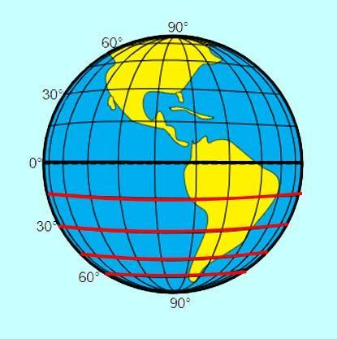
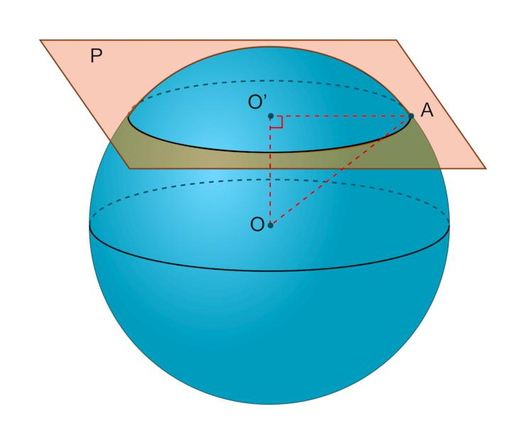
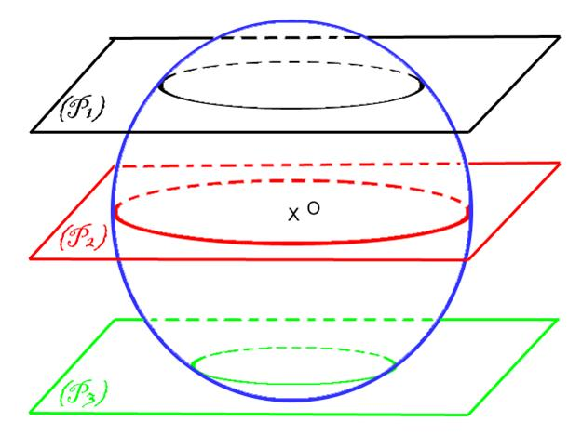

Definition
# Source: AI Source: Provided by: [Data Path: Persons Table -> ID Column: 1, Name_En Column: Motasem Essam] -> From: [ChatGPT] on [7/25/2026]
A southern small circle is a small circle on a sphere located south of a chosen equatorial plane or reference great circle. It is formed by the intersection of the sphere with a plane parallel to the equatorial plane that does not pass through the sphere’s center.
On Earth, any circle of latitude south of the Equator and north of the South Pole is a southern small circle. Examples include the Tropic of Capricorn and the Antarctic Circle.
Important distinction: “Southern” describes the circle’s position relative to the chosen equatorial reference. It does not define a different mathematical kind of circle.

Simple Definition
# Source: AI Source: Provided by: [Data Path: Persons Table -> ID Column: 1, Name_En Column: Motasem Essam] -> From: [ChatGPT] on [7/25/2026]
A southern small circle is a circular line around the southern part of a sphere, parallel to its equator and smaller than the equatorial great circle.

Classification
# Source: AI Source: Provided by: [Data Path: Persons Table -> ID Column: 1, Name_En Column: Motasem Essam] -> From: [ChatGPT] on [7/25/2026]
Circles on a Sphere
Small Circles
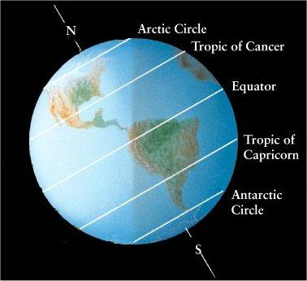
Northern Small Circle
Located north of the equatorial plane.
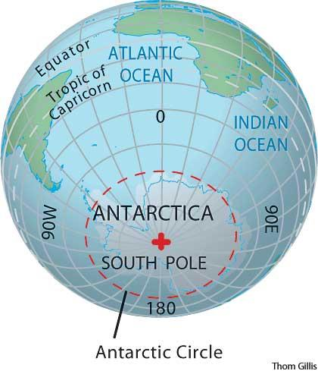
Southern Small Circle
Located south of the equatorial plane.
A small circle is produced by a plane that does not pass through the sphere’s center. In a latitude-based classification, a southern small circle lies below the equatorial plane when the positive vertical direction is north.

Geometric Structure
# Source: AI Source: Provided by: [Data Path: Persons Table -> ID Column: 1, Name_En Column: Motasem Essam] -> From: [ChatGPT] on [7/25/2026]
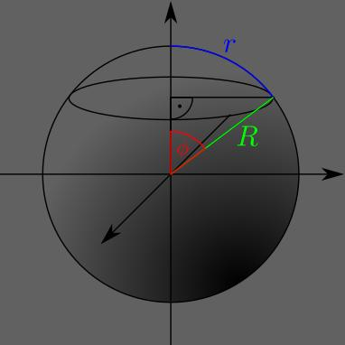
The principal geometric elements are:
- Sphere center $O$: The center of the sphere.
- Equatorial plane: The reference plane passing through the sphere’s center.
- Southern small-circle plane: A plane parallel to the equatorial plane and positioned south of it.
- Small-circle center $C$: The point where the sphere’s central axis intersects the small-circle plane.
- Sphere radius $R$: The distance from the sphere’s center to any point on its surface.
- Small-circle radius $r$: The distance from $C$ to any point on the small circle.
- Southern latitude $φ$: The angular latitude measured southward from the Equator.
- Plane offset $d$: The perpendicular distance from the sphere’s center to the small-circle plane.

Mathematical Representation
# Source: AI Source: Provided by: [Data Path: Persons Table -> ID Column: 1, Name_En Column: Motasem Essam] -> From: [ChatGPT] on [7/25/2026]
Consider a sphere centered at the origin with radius $R$, where the positive $z$-axis points north.
Sphere equation
$$x^{2}+y^{2}+z^{2}=R^{2}$$
Let $φ$ be the magnitude of the southern latitude, with $0^{∘}<φ<{90}^{∘}$.
Southern small-circle plane
The plane is located at
$$z=-R\sin{φ}$$
Substituting this into the sphere equation gives
$$x^{2}+y^{2}=R^{2}-R^{2}\sin^{2}{φ}$$
Using the identity $\cos^{2}{φ}=1-\sin^{2}{φ}$:
$$x^{2}+y^{2}=R^{2}\cos^{2}{φ}$$
Therefore, the small-circle radius is
$$\boxed{r=R\cos{φ}}$$
The perpendicular distance from the sphere’s center to the plane is
$$\boxed{d=R\sin{φ}}$$
The negative sign in the plane equation identifies the southern position; it does not change the circle’s radius.

Important Formulas
# Source: AI Source: Provided by: [Data Path: Persons Table -> ID Column: 1, Name_En Column: Motasem Essam] -> From: [ChatGPT] on [7/25/2026]
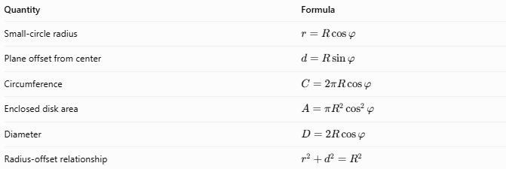
Quantity | Formula
Small-circle radius | $$r=R\cos{φ}$$
Plane offset from center | $$d=R\sin{φ}$$
Circumference | $$C=2πR\cos{φ}$$
Enclosed disk area | $$A=πR^{2}\cos^{2}{φ}$$
Diameter | $$D=2R\cos{φ}$$
Radius-offset relationship | $$r^{2}+d^{2}=R^{2}$$
Here, $R$ is the sphere’s radius and $φ$ is the magnitude of the southern latitude.

Worked Example
# Source: AI Source: Provided by: [Data Path: Persons Table -> ID Column: 1, Name_En Column: Motasem Essam] -> From: [ChatGPT] on [7/25/2026]
A spherical model has a radius of $12\text{ cm}$. Find the radius and circumference of its southern small circle at latitude ${60}^{∘}\text{ S}$.
Step 1 — Calculate the small-circle radius.
$$r=R\cos{φ}$$
$$r=12{\cos{60}}^{∘}=12\left(0.5\right)$$
$$\boxed{r=6\text{ cm}}$$
Step 2 — Calculate the circumference.
$$C=2πr=2π\left(6\right)$$
$$\boxed{C=12π≈37.70\text{ cm}}$$
Step 3 — Calculate the plane offset.
$$d=R{\sin{60}}^{∘}$$
$$d=12\left(\frac{\sqrt{3}}{2}\right)$$
$$\boxed{d=6\sqrt{3}≈10.39\text{ cm}}$$
Conclusion: The southern small circle has a radius of $6\text{ cm}$, a circumference of approximately $37.70\text{ cm}$, and lies about $10.39\text{ cm}$ south of the sphere’s center.

Comparison with Related Circles
# Source: AI Source: Provided by: [Data Path: Persons Table -> ID Column: 1, Name_En Column: Motasem Essam] -> From: [ChatGPT] on [7/25/2026]
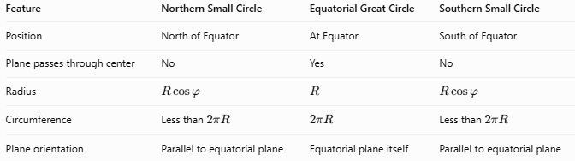
Feature | Northern Small Circle | Equatorial Great Circle | Southern Small Circle
Position | North of Equator | At Equator | South of Equator
Plane passes through center | No | Yes | No
Radius | $$R\cos{φ}$$ | $$R$$ | $$R\cos{φ}$$
Circumference | Less than $2πR$ | $$2πR$$ | Less than $2πR$
Plane orientation | Parallel to equatorial plane | Equatorial plane itself | Parallel to equatorial plane
At equal absolute latitudes, northern and southern small circles have identical radii, diameters, circumferences, and enclosed disk areas.

Examples and Applications
# Source: AI Source: Provided by: [Data Path: Persons Table -> ID Column: 1, Name_En Column: Motasem Essam] -> From: [ChatGPT] on [7/25/2026]
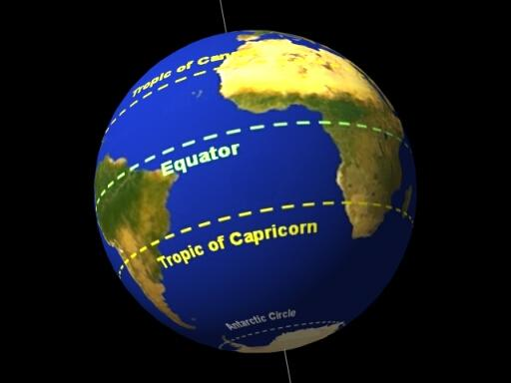
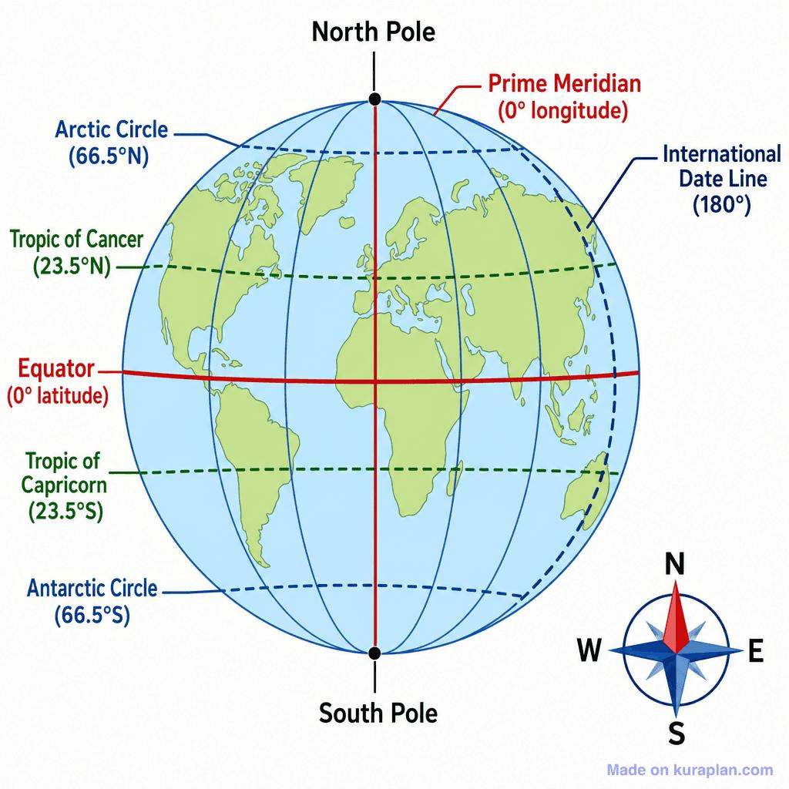
Examples on Earth include:
- Tropic of Capricorn: Approximately ${23.44}^{∘}\text{ S}$.
- Antarctic Circle: Approximately ${66.56}^{∘}\text{ S}$.
- Other southern latitudes: Any latitude strictly between the Equator and the South Pole.
Applications include:
- Geography and cartography.
- Measuring distances along circles of latitude.
- Navigation and spherical coordinate systems.
- Modeling intersections between spheres and parallel planes.
- Studying the relationship between latitude and circle circumference.

Key Points
# Source: AI Source: Provided by: [Data Path: Persons Table -> ID Column: 1, Name_En Column: Motasem Essam] -> From: [ChatGPT] on [7/25/2026]
- A southern small circle lies south of the equatorial plane.
- Its plane is parallel to the equatorial plane and does not pass through the sphere’s center.
- Its radius is $r=R\cos{φ}$.
- At the same absolute latitude, it has the same size as the corresponding northern small circle.
- Its circumference decreases as its latitude approaches ${90}^{∘}\text{ S}$.
- At the South Pole, the limiting circle shrinks to a point rather than remaining a proper circle.

Conclusion
# Source: AI Source: Provided by: [Data Path: Persons Table -> ID Column: 1, Name_En Column: Motasem Essam] -> From: [ChatGPT] on [7/25/2026]
A southern small circle is a circular intersection of a sphere with a plane parallel to the equatorial plane and located south of the sphere’s center. Its size depends on the sphere’s radius and its southern latitude. Unlike the equatorial great circle, it has a smaller radius and circumference because its plane does not pass through the center.

